FINAL PROJECT



HAIR SALON MANAGEMENT SYSTEM

Authors:

Andrea Pérez

Jon Andoni Baranda

Contents

Abstract 3

Snapshots 3

Startup 6

Extra Credit 7

1. Outstanding GUI 7

2. Github Repository 7

# Abstract

As the name implies the main purpose of this app is to manage a hair salon studio. The app is designed to be used by all kind of users, which includes: clients of the hair salon, workers of the business (considered Admins) and lastly owner or manager of the business.

Firstly, clients will be able to create an account, to sign in and to make reservations. Secondly, admins will be able to sign in and to manage all the reservations, as well as to delete or to update them. Lastly, managers have all the options available. This means they are able to create all type of users (clients, admins and managers), to delete any user and to manage reservations (the same way admins do).

# Snapshots

1. Showing a successful login for a regular user.

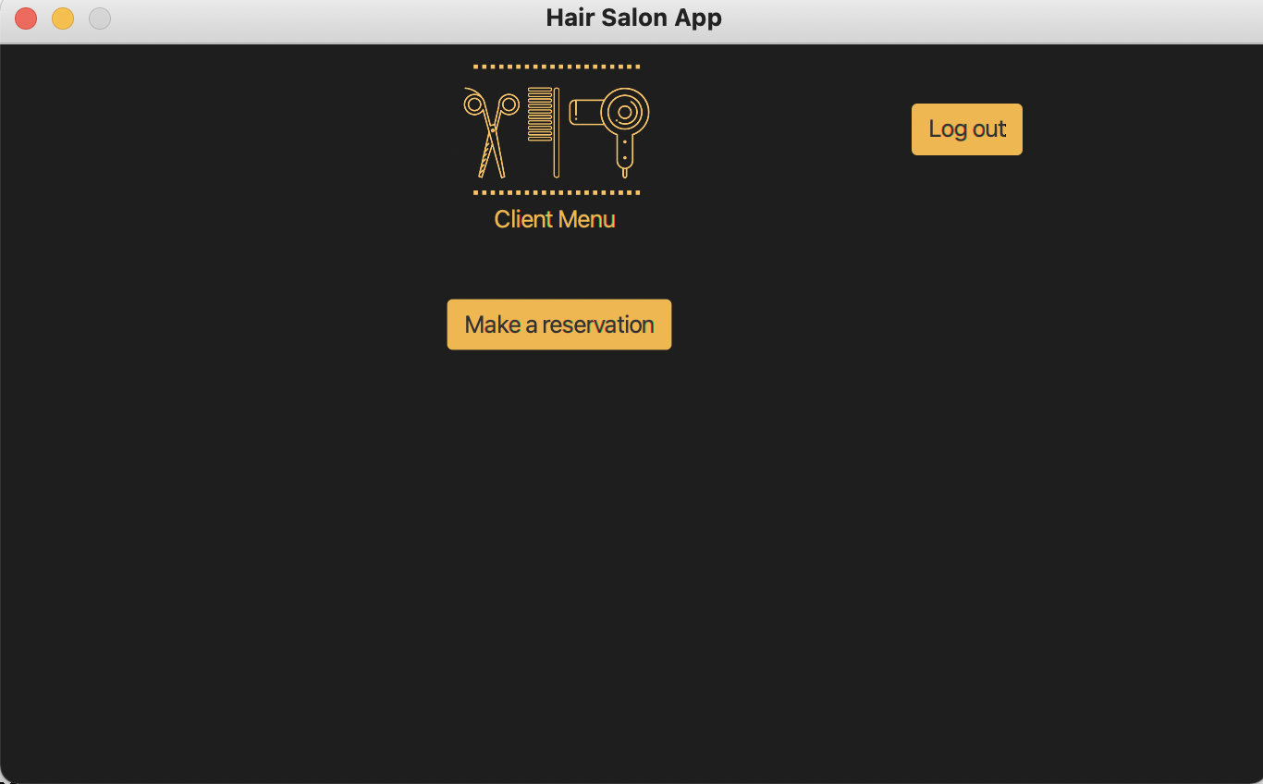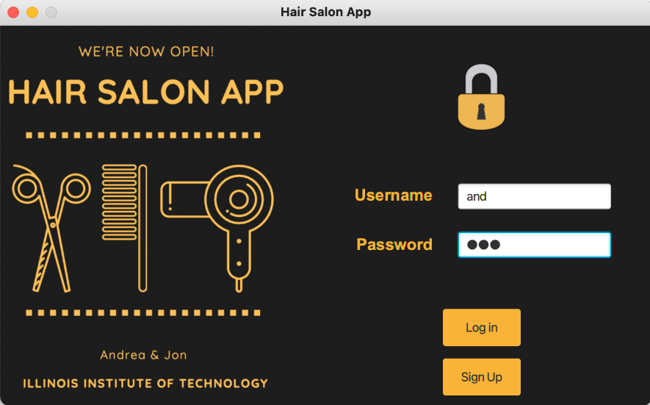

1. Show a successful login for an admin.

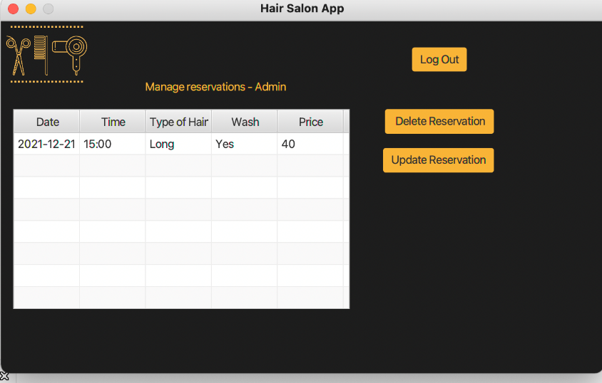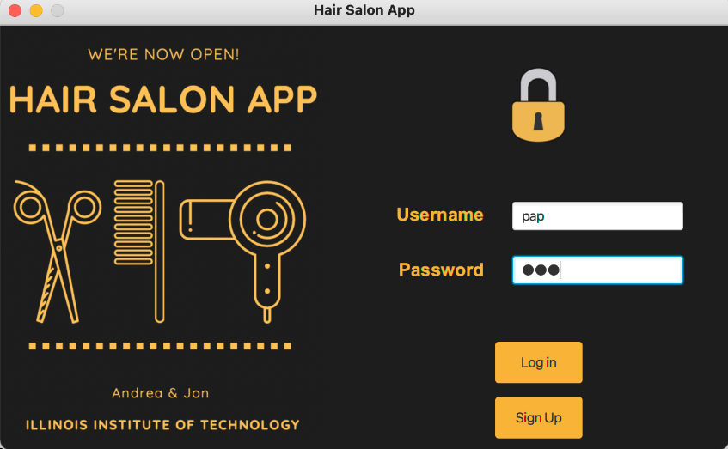

1. Show a result of all 10 records added to your database from the database itself.

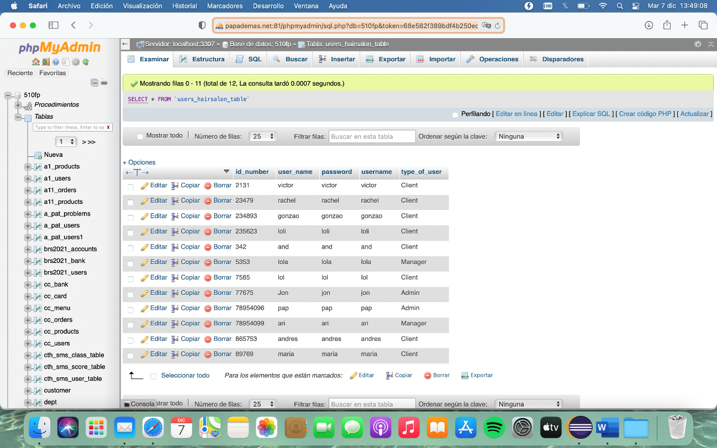Demonstrate sufficient functionality for the regular user. Ex. User enters a deposit and can view their new balance. Balance is retrieved by user id.

1. Show some update performed by the admin for the first record entered into the db.

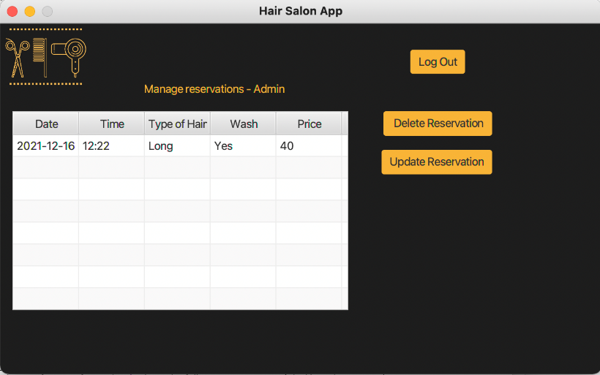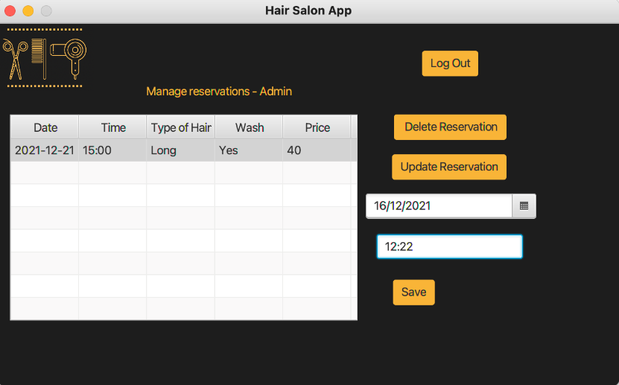

1. Show the deletion of the last record by the admin entered in the db and show a snapshot of your remaining records in some columnar view.

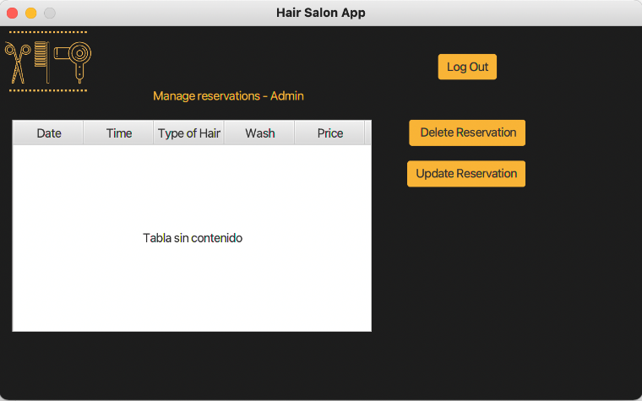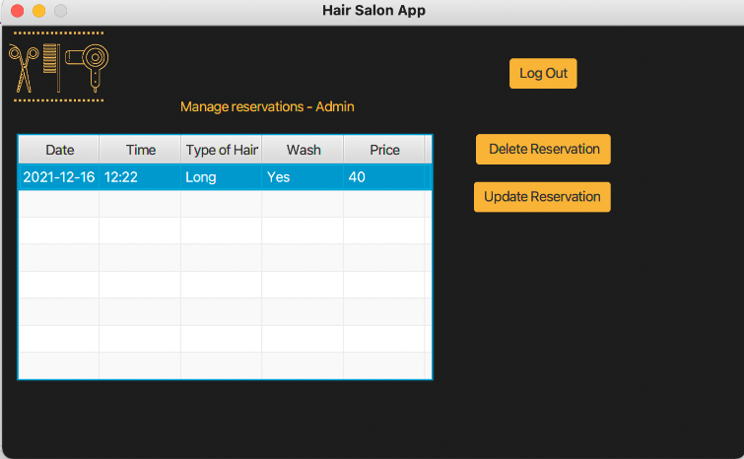

1. 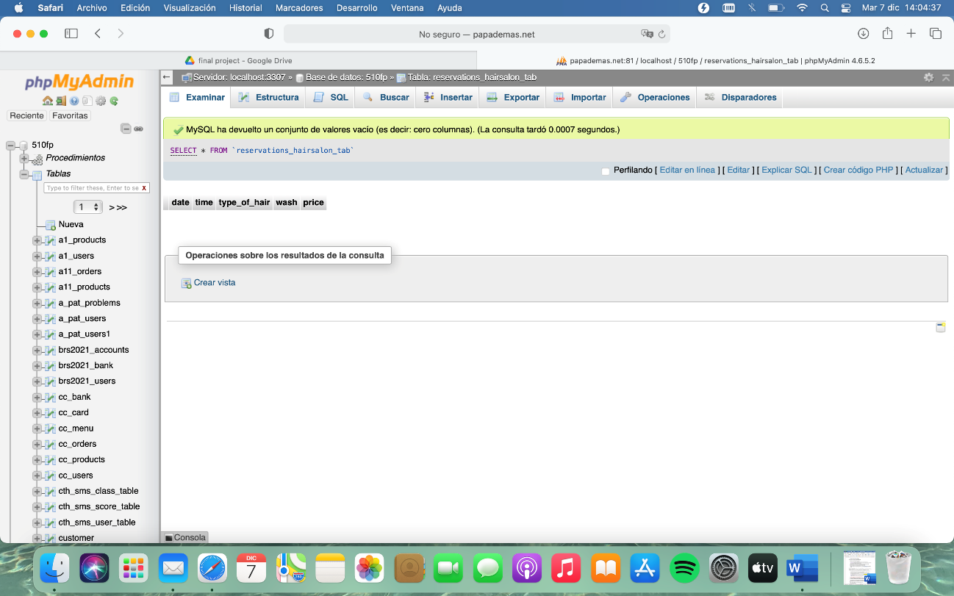Show a snapshot of your ending user table (i.e., the user login credentials) from the database itself.
2. Available options for a Manager user

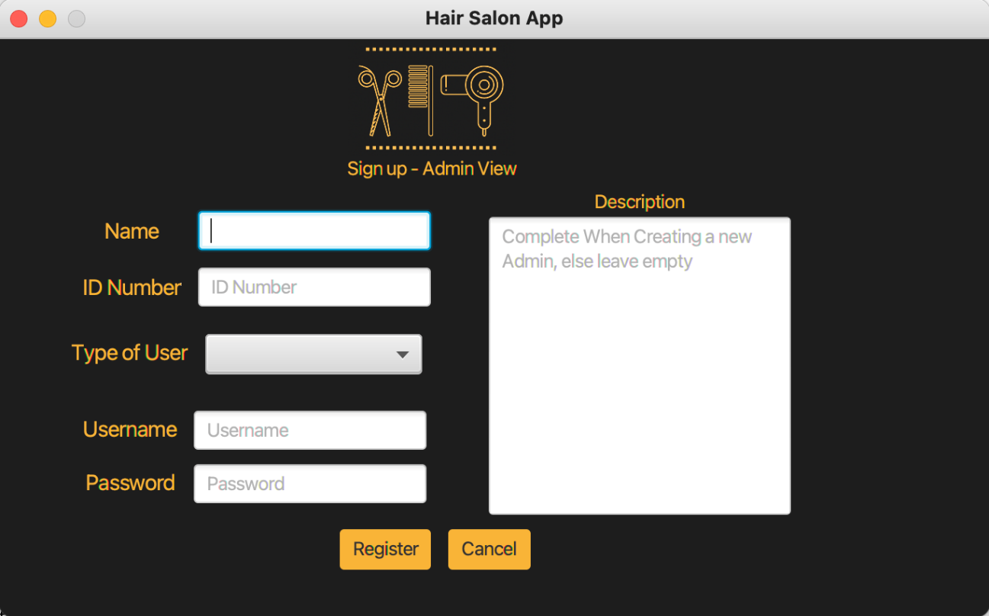

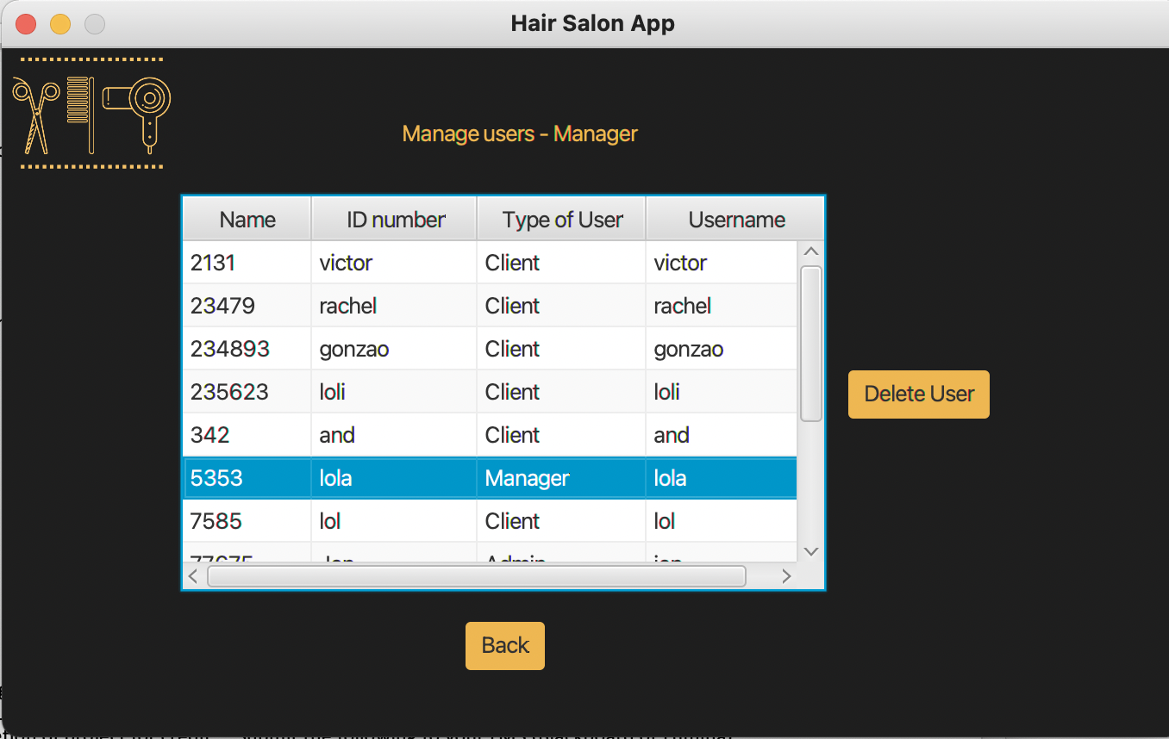

# Startup

In order to execute the program, the Java class called Main.java within the application package has to be run. For logging in, the login credentials are the following ones:

*Client user

username: and

password: and

*Admin user

username: pap

password: pap

*Manager user

username: ari

password: ari

# Extra Credit

## 1. Outstanding GUI

For this purpose, we have created a logo for the project that is used for the multiple windows, as well as the same style effects that creates a more appealing application for the users and a very predictable app so the user interactions are easy to understand and everyone can use the app without major problems.

## 2. Github Repository

The link for the Github repository is: <https://github.com/andreaperezisla/FinalProjectITMD>